**PYTHON OUTPUTS**

**Q2. Filtering the Text**

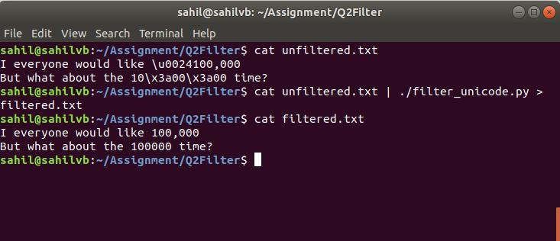

**Q3. Frequency Count**

1. **Using FILE (-f command)**

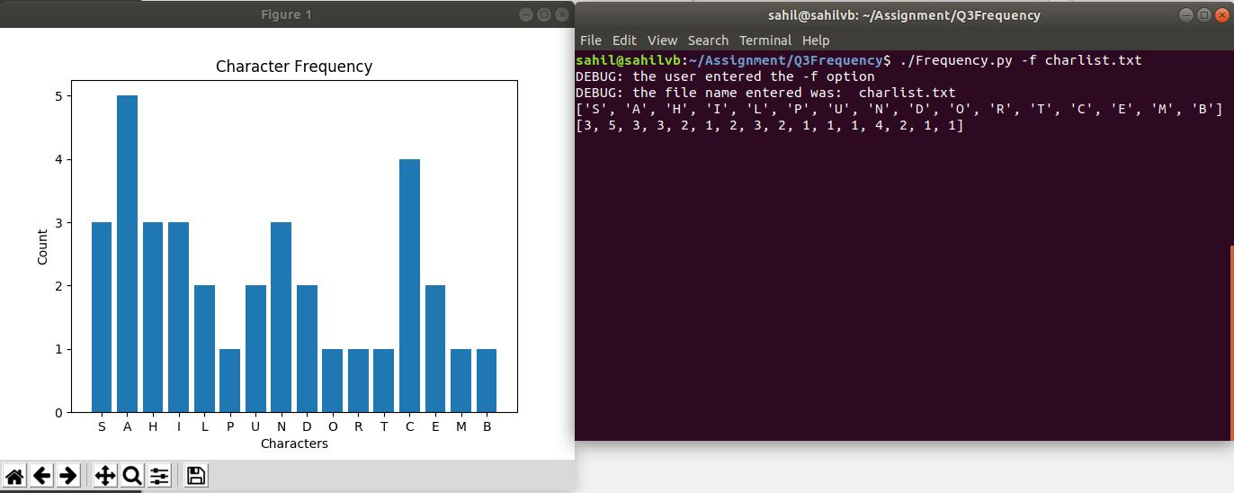

1. **Using CAT File Command**

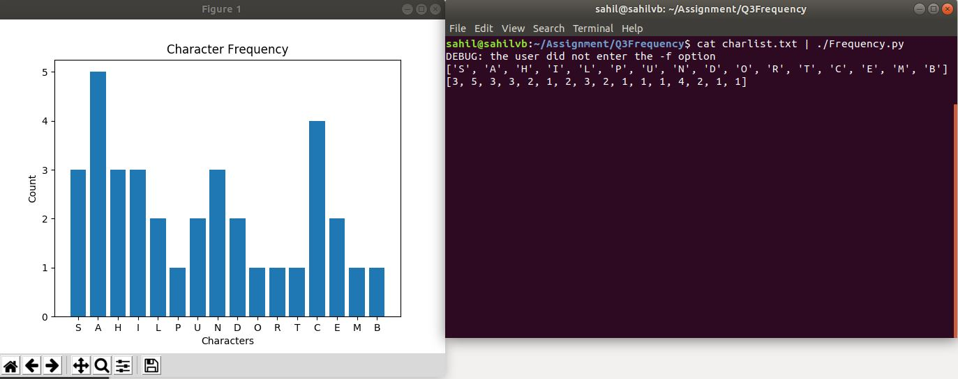

1. **Output**

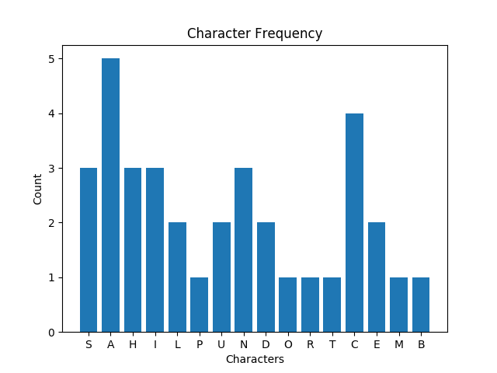

**Q4. DNA Decompose**

1. **Using Input on BASH Terminal**

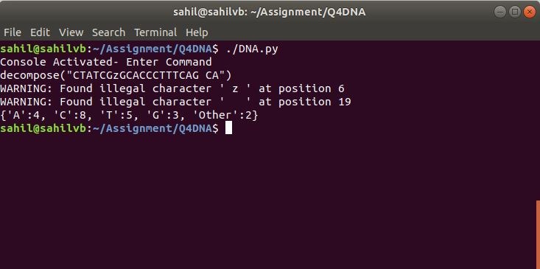

1. **Using CAT File command**

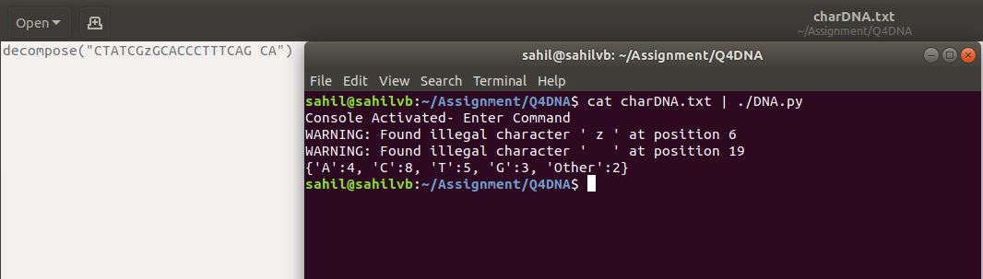

**Q5. Beta Function**

**A. Using input ‘Alpha’, ‘Beta’, ‘x’ values (total x values can be greater than or equal to 1)**

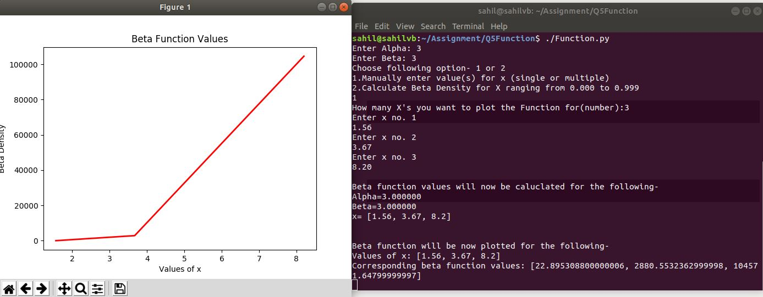

**B. Plotting for input ‘Alpha’, ‘Beta’ and ‘x’= Array from 0.000 to 0.999**

